Aetna Fitness Benefit Program Award
If you have any questions about these programs, please call the Member Services number on the back of your ID card.

FITNESS BENEFIT
Qualified Health Clubs
A qualified health club is one that offers a variety of cardiovascular and strength-training exercise equipment. These include traditional health clubs, YMCAs, and JCCs.
The Fitness Program Award does not apply to martial arts centers; gymnastics facilities; country clubs; tennis, aerobic, or pool-only facilities; social clubs; and sports teams or leagues. It also does not apply to aerobic/fitness activity fees (including those paid for personal training, lessons, coaching, exercise equipment, or clothing) paid to a non-qualified health club.

WHAT DO I NEED TO DO?
You can simply complete the enclosed Fitness Program Award claim form and send it to the Aetna address at the top of the form, along with:
● For Fitness Program Award reimbursement:
- A copy of your health club agreement or contract that includes the name and address of the health club and the membership or completed log including class dates (see attached). A minimum of 12 visits per month must be completed and/or walk 10K steps a day (or a combination there of). Member is limited to $240.00 reimbursement per year ($20 per month). Dependents must be over age 18 to be eligible.
- Note: Each 10K step day = one gym visit. Example: Submit 6 days of 10K steps and 6 days of Gym visits in a month would qualify as 1 monthly allowance. ATTESTATION BOX MUST BE CHECKED FOR STEP CREDIT.
- Photocopies of dated, paid receipts, or your bank or credit card statements, or paycheck stub if your club fees are automatically deducted from those accounts. Receipts or statements should include the name of the family member enrolled in the club and the individual charges for health club membership or class fees. Take a screen shot of your steps on your step tracking device i.e... phone, pedometer, smart watch.

Fitness Program Award Reimbursement Request | Submit Claims To:  Aetna  PO Box 981106  El Paso, TX 79998-1106  FAX: 1-859-455-8650
Failure to complete form in full may cause delay in payment.
Employee Instructions:
- Complete Parts 1 and 2 in full.
- Attach receipts for all expenses incurred for program reimbursement.
- You must meet the requirements described on the previous page.
Part 1
Employee Name (First, Middle, Last) |  | Date of Birth (MM/DD/YYYY) | Member ID Number
Employee Address (Street, City, State, ZIP Code)
Employer Name SCHOOLS HEALTH INSURANCE FUND -
Dependent Name(s) | Gender | Date of Birth  (MM/DD/YYYY) | Relationship to Insured
1. | M F
2. | M F
3. | M F
4. | M F
Part 2
Fitness Program
Address (Street, City, State, ZIP Code)
Program Attended | Health Club Reimbursement and Health Education  S9451 – Exercise classes, Gym membership
Date(s) Program Attended
Employee Certification
I certify that these expenses were incurred by myself or an eligible dependent. These classes were attended for the full term of the class offered and attendance can be verified by the provider listed above.
By checking this box, I attest to having logged a minimum of 10K steps.
Employee’s Signature Date

Fitness Reimbursement Log

Member name ___________________________________________ Aetna ID # _____________________________
***please write “10K STEPS” for each day below completed***

Instructor/fitness center representative must acknowledge each workout with a date and signature. Credit will only be issued for workouts completed during supervised hours.
Fitness center Fitness center
Date representative signature Workout time Date representative signature Workout time
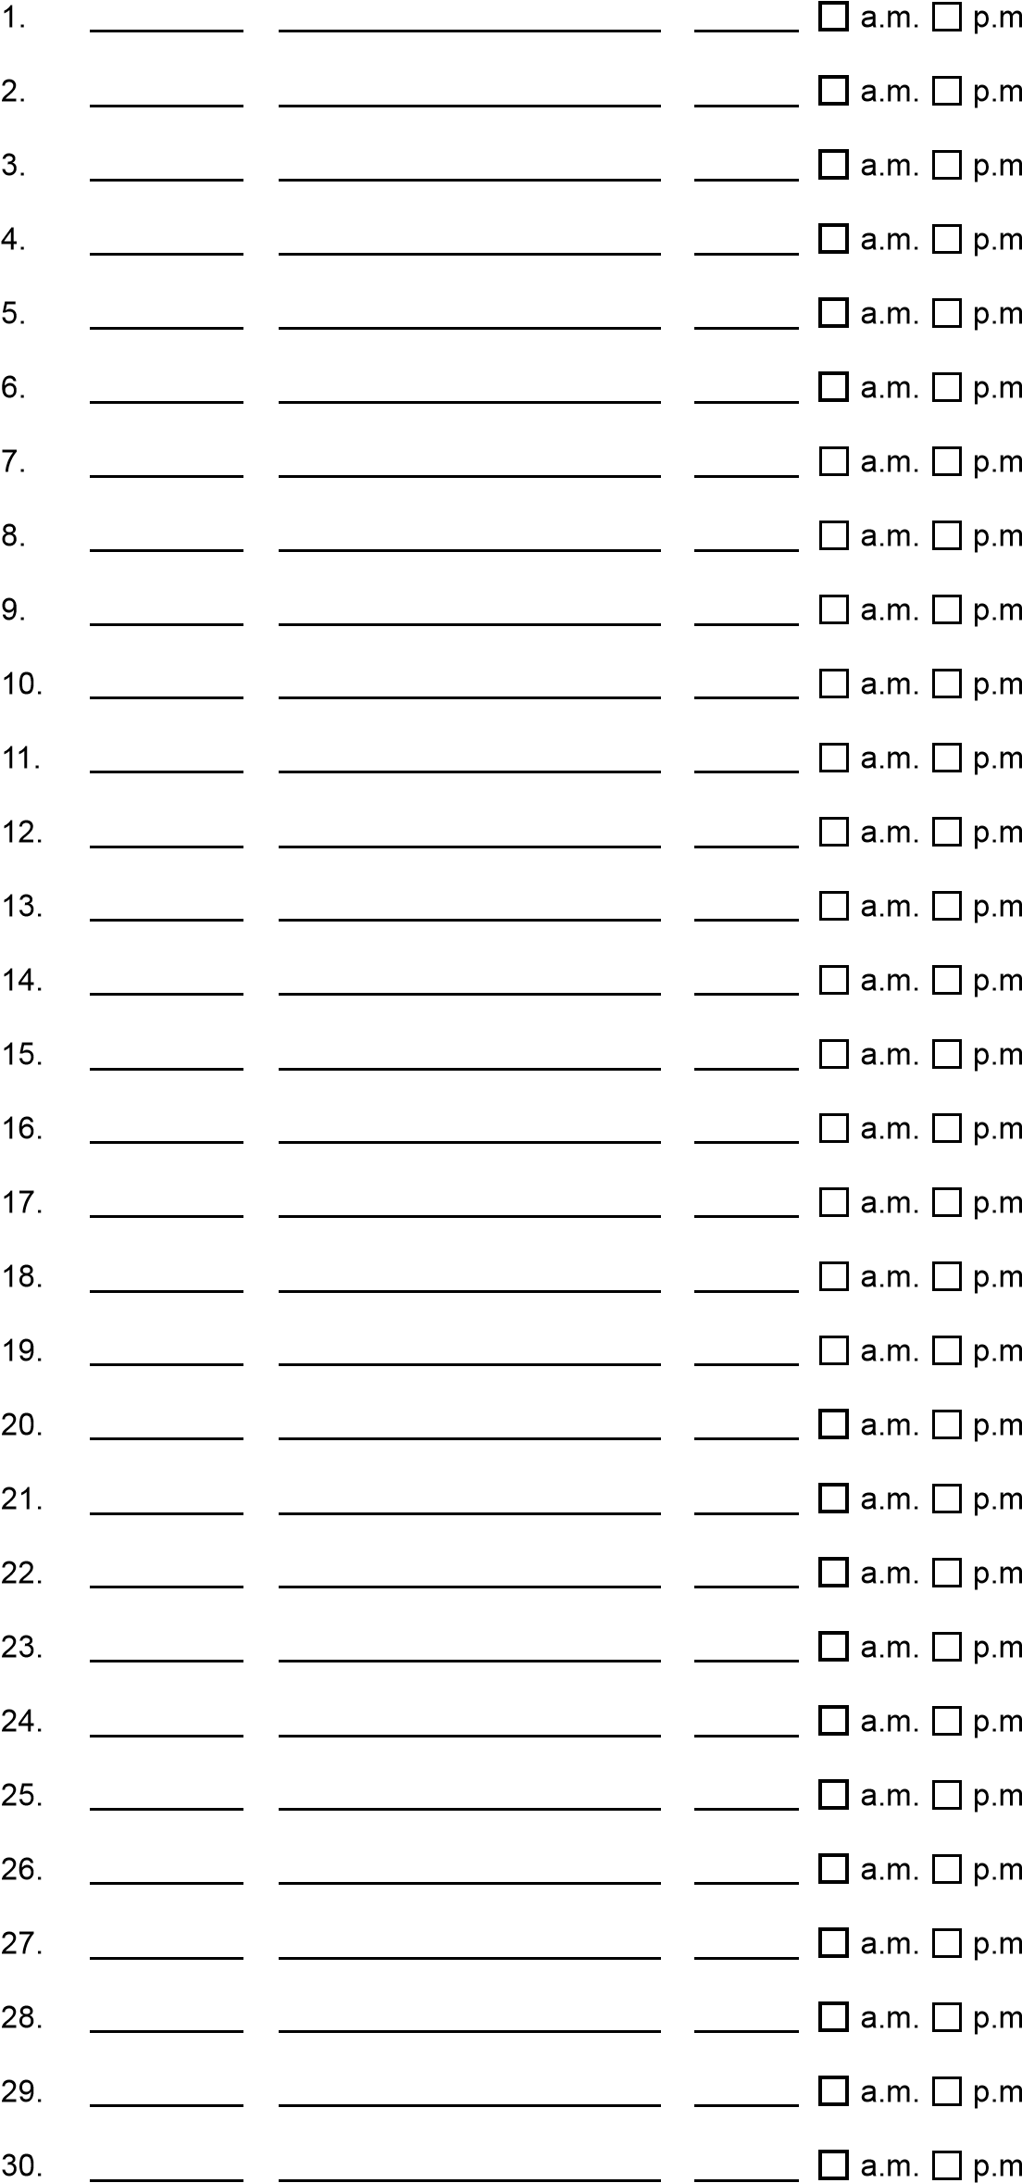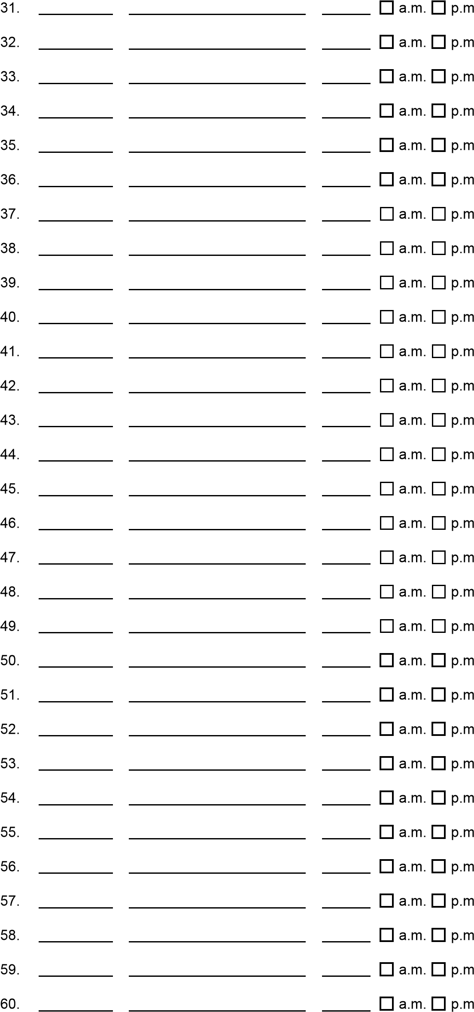
Aetna may verify your workouts with your fitness center. Only one session per day and seven sessions per week with a minimum of eight hours between logged workouts will be credited.

Fitness Reimbursement Log

Member name Aetna ID # _____________________

Instructor/fitness center representative must acknowledge each workout with a date and signature. Credit will only be issued for workouts completed during supervised hours.
Fitness center Fitness center
Date representative signature Workout time Date representative signature Workout time
